Machine Problem 1: Predefined Functions

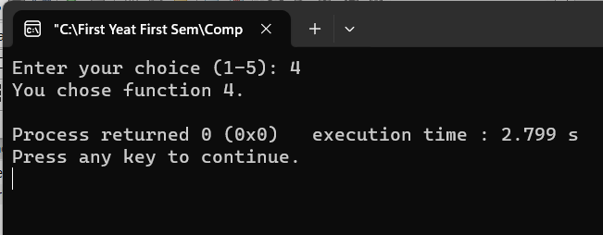

Here is my C++ Code:
#include <iostream>

using namespace std;

void function1() {
cout << "You chose function 1." << endl;
}

void function2() {
cout << "You chose function 2." << endl;
}

void function3() {
cout << "You chose function 3." << endl;
}

void function4() {
cout << "You chose function 4." << endl;
}

void function5() {
cout << "You chose function 5." << endl;
}

int main() {
int choice;

cout << "Enter your choice (1-5): ";
cin >> choice;

switch (choice) {
case 1:
function1();
break;
case 2:
function2();
break;
case 3:
function3();
break;
case 4:
function4();
break;
case 5:
function5();
break;
default:
cout << "Invalid choice." << endl;
break;
}

return 0;
}

Base on what I saw in w3school this is one of the tutorials that I understand the “Function System”. Also sir my code was copied from my Visual Studio Code that is why the background and the colors were different.

Machine Problem 2: Quiz System
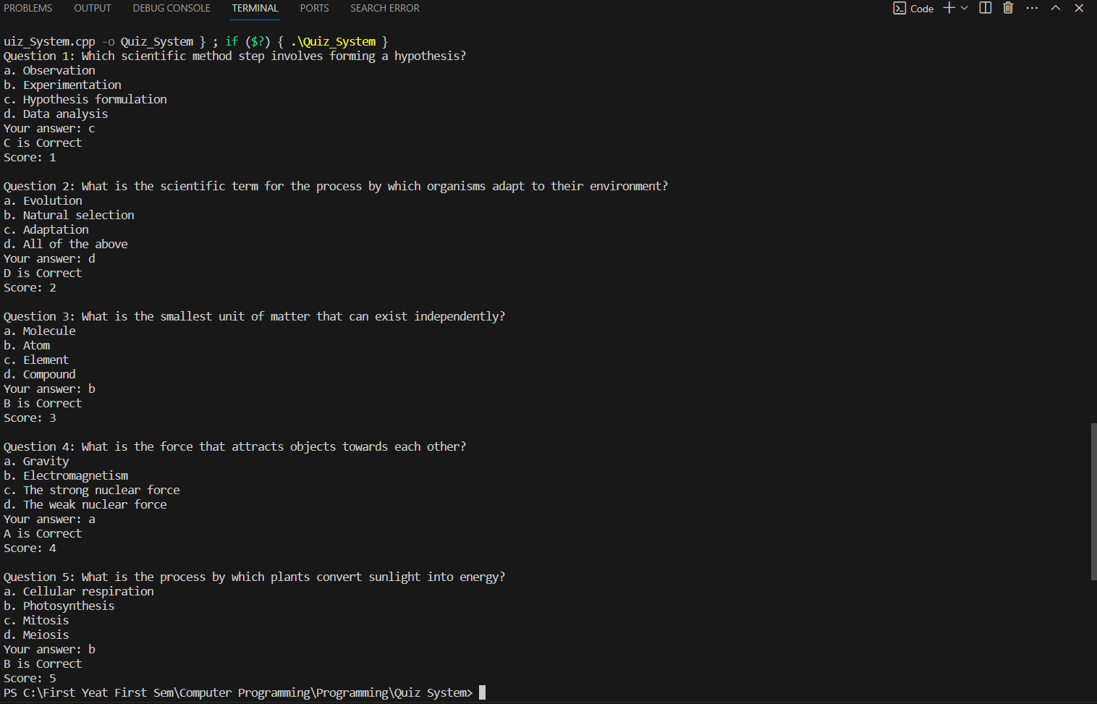

Here is my C++ Code:
#include <iostream>

using namespace std;

int main() {
int score = 0;

//Science Quiz System
// Question 1
cout << "Question 1: Which scientific method step involves forming a hypothesis?" << endl;
cout << "a. Observation" << endl;
cout << "b. Experimentation" << endl;
cout << "c. Hypothesis formulation" << endl;
cout << "d. Data analysis" << endl;
cout << "Your answer: ";

char answer;
cin >> answer;

switch (answer) {
case 'c':
cout << "C is Correct" << endl;
score++;
break;
default:
cout << "Incorrect" << endl;
break;
}

cout << "Score: " << score << endl;

// Question 2
cout << "\nQuestion 2: What is the scientific term for the process by which organisms adapt to their environment?" << endl;
cout << "a. Evolution" << endl;
cout << "b. Natural selection" << endl;
cout << "c. Adaptation" << endl;
cout << "d. All of the above" << endl;
cout << "Your answer: ";

cin >> answer;

switch (answer) {
case 'd':
cout << "D is Correct" << endl;
score++;
break;
default:
cout << "Incorrect" << endl;
break;
}

cout << "Score: " << score << endl;

// Question 3
cout << "\nQuestion 3: What is the smallest unit of matter that can exist independently?" << endl;
cout << "a. Molecule" << endl;
cout << "b. Atom" << endl;
cout << "c. Element" << endl;
cout << "d. Compound" << endl;
cout << "Your answer: ";

cin >> answer;

switch (answer) {
case 'b':
cout << "B is Correct" << endl;
score++;
break;
default:
cout << "Incorrect" << endl;
break;
}

cout << "Score: " << score << endl;

// Question 4
cout << "\nQuestion 4: What is the force that attracts objects towards each other?" << endl;
cout << "a. Gravity" << endl;
cout << "b. Electromagnetism" << endl;
cout << "c. The strong nuclear force" << endl;
cout << "d. The weak nuclear force" << endl;
cout << "Your answer: ";

cin >> answer;

switch (answer) {
case 'a':
cout << "A is Correct" << endl;
score++;
break;
default:
cout << "Incorrect" << endl;
break;
}

cout << "Score: " << score << endl;

// Question 5
cout << "\nQuestion 5: What is the process by which plants convert sunlight into energy?" << endl;
cout << "a. Cellular respiration" << endl;
cout << "b. Photosynthesis" << endl;
cout << "c. Mitosis" << endl;
cout << "d. Meiosis" << endl;
cout << "Your answer: ";

cin >> answer;

switch (answer) {
case 'b':
cout << "B is Correct" << endl;
score++;
break;
default:
cout << "Incorrect" << endl;
break;
}

cout << "Score: " << score << endl;

return 0;
}

Hi sir! my code was copied from my Visual Studio Code that is why the background and the colors were different.

